CROATIA ITINERARY

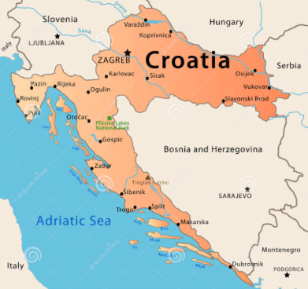

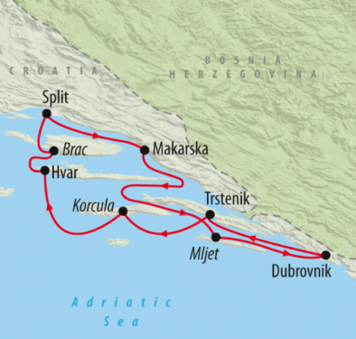

***Split Airbnb address***

Senjska ulica 64, Split

Splitsko-dalmatinska

Županija 21000

***Zagreb Airbnb address***

Vlaska ulica 58 Smiciklas,

Zagreb, 10000 Croatia

|  |  |
| --- | --- |
| **Date** | **Activities** |
| Sunday, March 11 | Arrive in Zagreb @ 2:00pm, airport shuttle to main airport, bus to Split @ 4:00pm |
| Monday,  March 12 | Go down to Riva waterfront for lunch (Matejuska port area), Bokeria Kitchen & Wine for dinner |
| Tuesday,  March 13 | Day trip to sail the Palkeni Islands, Hvar, dinner on the coast |
| Wednesday, March 14 | Explore old neighborhoods: Varos, Dobri, Lucac and Manus, bus back to Zagreb, check into Zagreb Airbnb |
| Thursday, March 15 | Secret Zagreb walking tour |
| Friday, March 16 | Explore Zagreb: lunch with ladies, Museum of Broken Relationships, |
| Saturday, March 17 | Plitvice Lakes National Park day trip |
| Sunday, March 18 | More Zagreb |
| Monday, March 19 | Food exploring, flight in evening |

**Booked transportation log**

|  |  |
| --- | --- |
| March 11 | Zagreb airport to Zagreb main bus station @ 2pm  Zagreb main bus station to Split bus station @ 4pm  Cab/Uber from Split bus station to Split Airbnb |
| March 12 | None |
| March 13 | None |
| March 14 | Split to Zagreb main bus station @ 3:45  Cab/Uber from Zagreb main bus station to Zagreb Airbnb |
| March 15 | None |
| March 16 | None |
| March 17 | Zagreb to Plitvice @ 10:30  Plitvice to Zagreb @ 16:25 |
| March 18 | None |
| March 19 | Cab to Zagreb airport |

**NOTES**

**March 11**: The bus can be found just outside the door by the Tourist Information Office in the International Arrivals area. The bus has a placard in its front window to identify it.

**March 12**: the fish market and boat port, Matejuska is on the west end of Riva, address of Bokeria Kitchen and Wine: Domaldova 8, Split

**March 15**: Meet at Zagreb Cathedral: by the fountain with the golden statues